MF0 Demo User Manual

Manual Name：MF0 Demo User Manual
Manual NO ：
Version：V1.0

Total 7 pages
(Including cover)

Compose ZhangYong
Review
Countersign

Cilico Microelectronics Co., Ltd
Modifiy record
File No. | Version | Composed By / Modified By | Compose / Modify Date | Modify Reason | Major changes  （Write main Points） | Review By
 | V1.0 | ZhangYong | 2017.03.27 | None | None | ShiLiangYi
Note: When the file is prepared for the first time, write “None” on "Modify Reason" and "Major modifications columns.

Contents

1. Purpose 4
2. Applicable scope 4
3. Install APK 4
4. Open NFC Service 4
5. Launcher App 4
6. Card discover 5
7. Card information 5
8. Card manager 5
8.1 read 5
8.2 write 6
9. Help 6

1 Purpose
Guide how to identify MF0 card, how to read the card data, how to write data to the card, and how to lock card.
2 Applicable scope
Use for the IOT handheld terminals which supports the NFC-enabled .
3 Install APK
First ensure that the device supports the NFC function, Then check whether the device had install this APP, if it was not installed，so install NfcManager.apk。
4 Open NFC Service
First open the “Setting” App ，Then select “more”options of “Wireless & networks”group,，Last select “NFC”options，and open NFC service，and open “Tag reading & writing”。
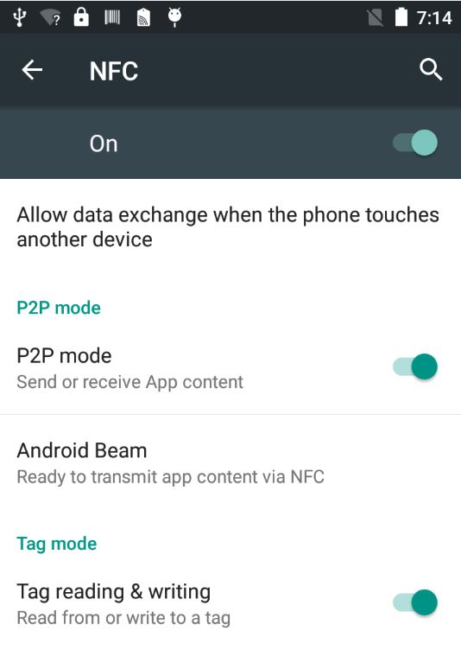

5 Launcher APP
Click the NFC APP Icon to launcher it. 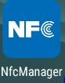
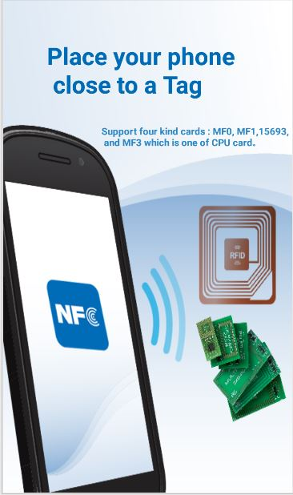
6 Card Discover
Put the MF0 type card into the back of the handheld terminal. After hearing the sound of "toot" , the application interface will automatically pop up, so keep the card not to be moved。
7 Card Infomation
After the card is successfully identified, the basic information of card is parsed and displayed in the top area
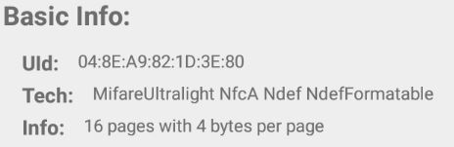
8 Card Manager
8.1 Read
First choose the start page No. , then click the "read" button, the results will be displayed in the bottom.
Note: Each time four pages of data are read by default.
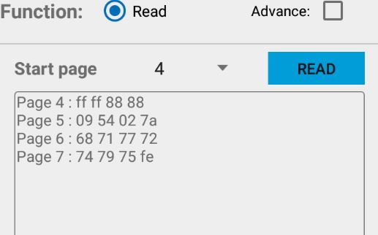
8.2 Write
8.2.1 Show Write Function
First select the start page No. , then input the maximum 4 bytes hexadecimal, and click the "write" button to write data. success or failure will be displayed at the bottom.

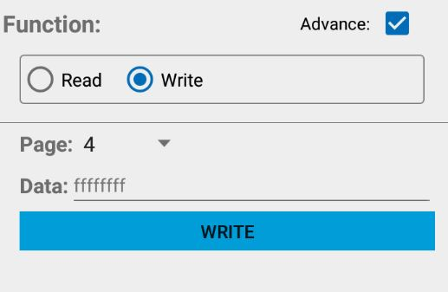
9 Help
Click the upper right corner of the icon, enter the help interface, which describes the MF0 card basic information, as well as some operating instructions.

